Support DuPagePads - Host a Fundraiser!
DuPagePads’ mission is to end homelessness in DuPage County. By hosting a fundraiser,
you can help empower families and individuals to work toward a place to call home. Consider the fundraising ideas below or create your own.
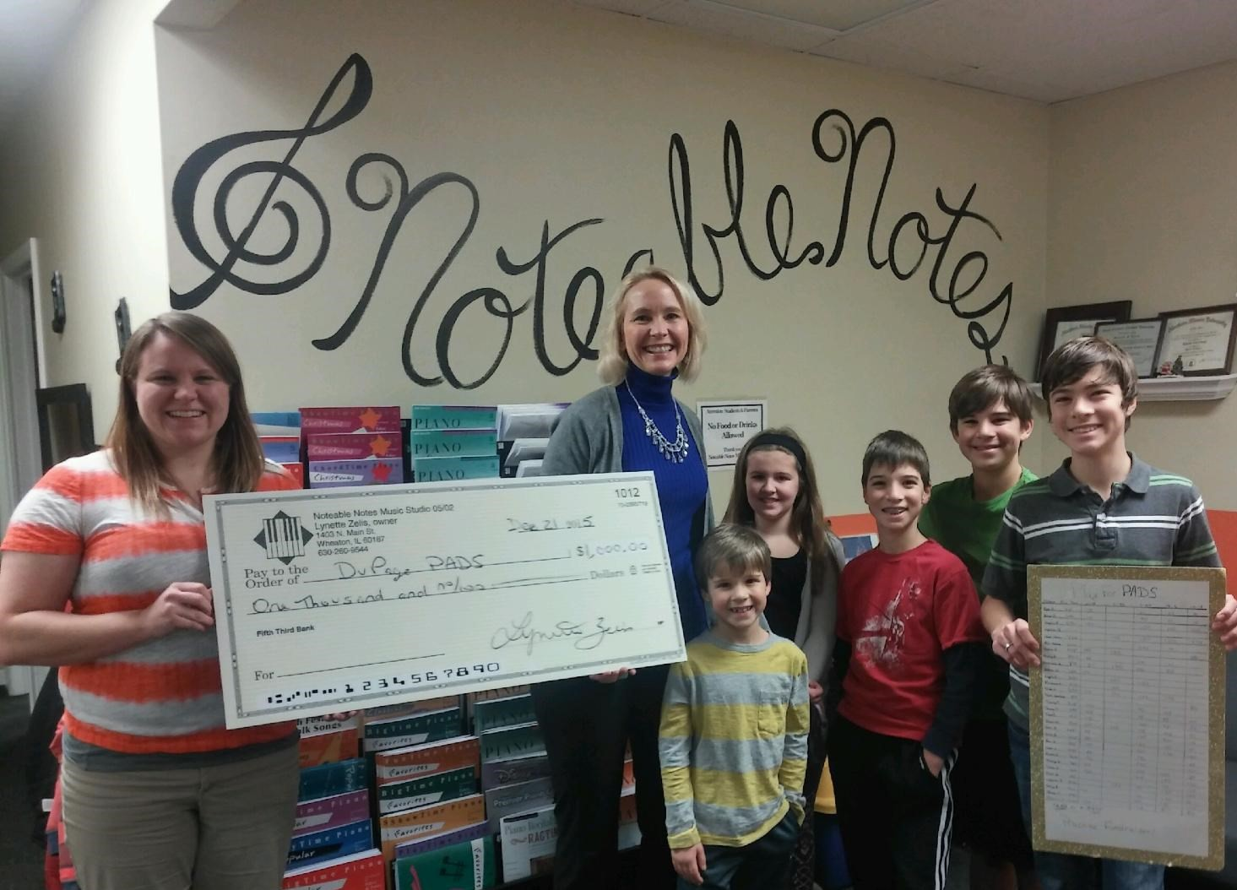
Get Your Business Involved
- Host a Percentage Giveback Day
- Donate to a Dress Casual Work Day
- Ask customers to “round up” their payment and give the change as a donation
- Offer matching donations

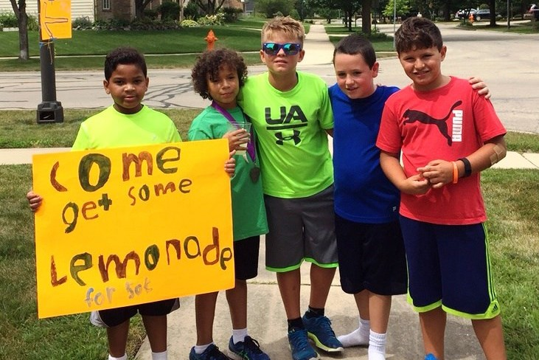
Get Your Family Involved
- Donate in lieu of birthday gifts
- Organize a Run or Walk-a-thon
- Set-up a Lemonade Stand
- Have a Garage Sale

Get Your Service Club
Involved
- Organize a Penny Drive
- Host a Bake Sale
- Hold a Concert
- Offer your gift wrapping services

… AND MORE!!
For more information on how you can support our mission, please contact Carrie Flick: 630.682.3846, ext. 2290 or CFlick@dupagepads.org.

